**DAILY ONLINE ACTIVITIES SUMMARY**

|  |  |  |  |  |  |  |  |
| --- | --- | --- | --- | --- | --- | --- | --- |
| **Date:** | **18/06/2020** | | | | **Name:** | Tushit Shukla | |
| **Sem & Sec** | **4 SEM & B SEC** | | | | **USN:** | **4AL18CS093** | |
| **Online Test Summary** | | | | | | | |
| **Subject** | | - | | | | | |
| **Max. Marks** | | - | | **Score** | | - | |
| **Certification Course Summary** | | | | | | | |
| **Course** | **PYTHON PROGRAMMING** | | | | | | |
| **Certificate Provider** | | | **Great Learning** | **Duration** | | | **1.5 hr(spent by me on that day to learn)** |
| **Coding Challenges** | | | | | | | |
| **Problem Statement:**  1 A magic number is defined as a number which can be expressed as a power of 5 or sum of unique powers of 5. First few magic numbers are 5, 25, 30(5 + 25), 125, 130(125 + 5), …. Input: n = 1 Output: 5  Input: n = 2 Output: 5 25  Input: n = 3 Output: 5 25 30  Input: n = 8 Output: 5 25 30 125 130 150 155 625  Hint: The magic numbers can be represented as 001, 010, 011, 100, 101, 110 etc, where 001 is 0*pow(5,3) + 0*pow(5,2) + 1*pow(5,1). So basically, we need to add powers of 5 for each bit set in given integer n. If n = 1; binary representation of 1 = 0001 Magic Number is: 0 * pow(5,4) + 0 * pow(5, 3) + 0 * pow(5, 2) + 1 * pow(5, 1) = 5  If n = 6; Binary representation of 6 is 0110 6th Magic Number is: 0 * pow(5, 4) + 1 * pow(5, 3) + 1 * pow(5, 2) + 0 * pow(5, 1) = 0 + 125 + 25 + 0 = 150  Logic:  Read n for(i = 0 to n) { Display ith magic number } | | | | | | | |
| **Status: Completed** | | | | | | | |
| **Uploaded the report in Github** | | | | **Yes** | | | |
| **If yes Repository name** | | | | <https://github.com/tushitshukla29/lockdown-program> | | | |
| **Uploaded the report in slack** | | | | **Yes** | | | |

**Online Certification Details**

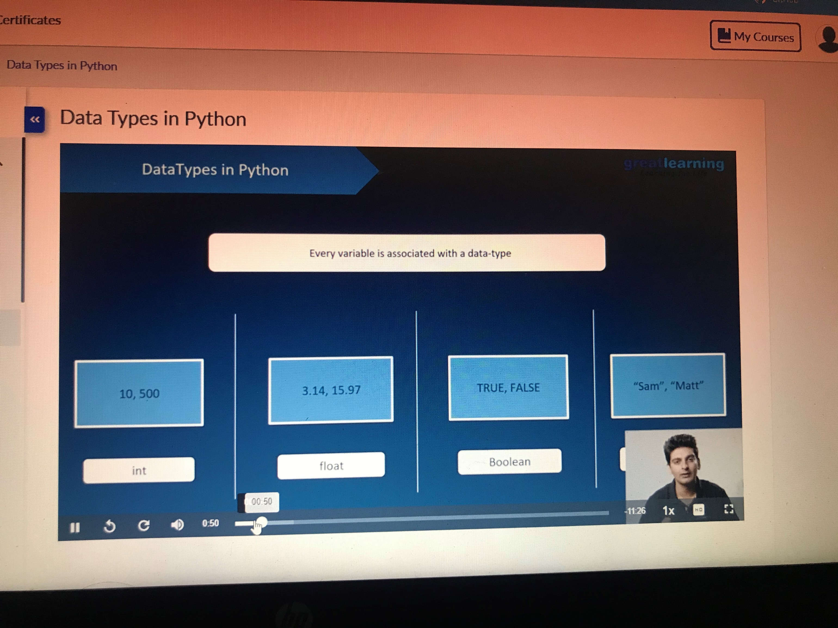

**Coding Challenge Details**

1. <https://github.com/tushitshukla29/lockdown-program/blob/master/magicnumber>